**Customer Testimonial**

Meelunie relies on the security label tesa PrioSpotby tesa scribos, enabling wholesalers, retailers and customers to easily distinguish its high quality products from counterfeit merchandises flooding the global market, especially from Asian countries.

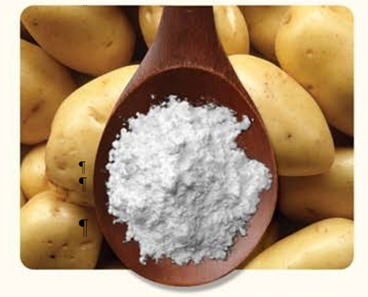

**The introduction of the** [**tesa PrioSpot**](http://www.tesa-scribos.com/fra/technologies_securite/tesa_priospot/tesa-priospot-protection-des-produits-et-prevention-des-marches-paralleles-avec-un-niveau-de-securite-maximum,8826349,1.html) **security label and a clear communication campaign allowed Meelunie, one of the leading potato starch suppliers worldwide, to make significantly steps to reduce the volumes of counterfeit copies of its 150 year old well-known brand « Windmill ».**

**Company background**

Meelunie was founded in Holland in 1867. In the beginning, it started with the production of potato starch, which was produced in a windmill and was mainly destined for food and industrial applications in the Netherlands. Since then, the company has commercialized many different high-quality products to the food and feed industry in more than 80 countries worldwide, with Windmill still being its strongest brand image and representing a significant part of the market share.

The company’s potato starch business really took off after World War II, when a container, destined to Singapore, accidentally arrived in Hong Kong. There, nobody knew what to do with it and the container was put on sale in an auction house. It was finally bought by M. Lam senior, who discovered the outstanding characteristics of potato starch in the preparation of soups and sauces. He started educating the local Cantonese kitchen chefs on how to use it. The product’s unique peak viscosity and clarity made it stand out in comparison to other starch and M. Lam senior then became the main distributor of Windmill potato starch for the Asian market and is still in business with Meelunie today.

Since then, the use of potato starch has significantly increased in the Cantonese / Chinese kitchen and Windmill became a trusted brand by its users, the chefs. With the opening of the Chinese economy and the emigration of many Chinese families to other parts of the world, the Windmill brand became globally recognized as the ingredients of choice for the Cantonese kitchen.

**Challenge**

Although Windmill branded potato starch is sold globally nowadays, China, Hong Kong and Taiwan are Meelunie’s most important markets in terms of volume and turnover. Unfortunately it is specifically in those markets where the principle of brand ownership and intellectual property is different compared to the Western world. As a consequence, Meelunie has seen a steady growth of counterfeit material coming into the market over the years, ranging from 30 to 50 percent of the total of the Windmill potato starch volumes in the market, according to estimations made by Meelunie’s key distributors in 2014. Even without reliable data available, if only half of the lowest value was true, this meant a more than significant leakage of business for the Dutch firm.

*“Additionally, when talking about a counterfeit problem, it is not only lost business that is at stake, but also the risk of a damaged brand quality perception. In our case, the counterfeit material involves both the packaging as well as the raw material itself. When the counterfeiters use lower grade potato starch from alternative European or Chinese sources and sell this material in counterfeit Windmill bags, the perceived quality of the Windmill brand is affected”,* Jan van Vilsteren, Sales Manager at Meelunie, Netherlands, says. *“To take the issue a step further, if other materials than potato starch are used to fill the bags, there could be a potential food-safety issue with a much more disruptive effect on our brand equity and business, not only in that region but on a wider scale as well.”*

**Solution**

To avoid these risks, the company decided at the end of 2014, to look for a viable solution, both via the Internet and through its network of trusted partners. After a pre-selection, discussions started in early 2015 with five different solution providers including Fujifilm (Japan), Dupont (UK), NJ Intelligence (China) and KPMG, a Dutch consulting firm. All of them were offering solutions based mainly on holograms. Meelunie’s final selection was tesa scribos, who turned out to be the only company 100% specialized and highly experienced in brand protection and anti-counterfeit solutions based on QR codes combined with various other sophisticated technologies, developed internally.

Furthermore, the tesa scribos solution had been presented and highly recommended to Meelunie by its partner and exclusive supplier of the Windmill bags: Segezha in Denmark. The latter was already applying tesa scribos security labels for another client as a brand protection solution on cement bags, a completely different market yet one that was faced with similar issues regarding the possible damage and harm of counterfeits.

Within a space of only two months, Meelunie had found the right solution, finished negotiations and worked with tesa scribos on a customized security label to suit the needs of the company. The final design was approved in February 2015. The order was signed in March and the labels delivered to the bag manufacturer in June. The first Windmill bags protected with the tesa scribos security label were produced in July 2015 and appeared on the market in August 2015.

**How to inform the market of positive communications and a competitive advantage through a successful anti-counterfeit campaign**

In parallel, Meelunie worked with tesa scribos on an effective communications campaign, an important element that should not be neglected if an anti-counterfeit concept is to be a success. Such campaigns seem even more crucial for products with quite a long shelf life. In the case of the Windmill potato starch, this meant a period of 24 months in which a mix of products with and without the security label would be found on the market.

In order to avoid any confusion and doubts, Meelunie designed and personally introduced a flyer to its distributors to explain the new security label, how it worked, its benefits for the distributors and their respective resellers.

As the market is quite transparent and in an attempt to reach out to end-customers as well, Meelunie has also launched advertising campaigns to remind or present and explain to readers about the anti-counterfeit tools in place.

**tesa PrioSpot and tesa connect & check**

The solution chosen by Meelunie to protect its high quality Windmill products and brand image consists of a security label ‘tesa PrioSpot’ on each potato starch bag and an additional online tool - the ‘tesa connect & check’ platform. By scanning the QR code with a Smartphone or going on the website, distributors, resellers, customs officials and end-users can get information on how to confirm further proof points for the authenticity of the product.

Both tools are well explained in a detailed information flyer for Meelunie’s partner network as follows:

**Certificate of Authenticity on Windmill potato starch (effective from production date August 2015)**



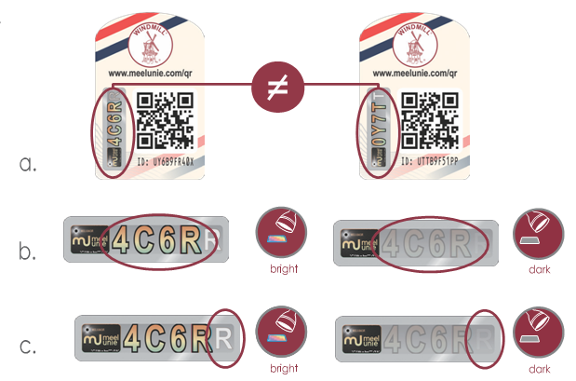**To prove that the product is authentic:**

1. Every Windmill bag has a unique

security code

1. The security code appears differently

in direct light than in diffused light

1. A moving digit becomes visible when

tilting the product in direct light

**Scan QR code or go to the website:**

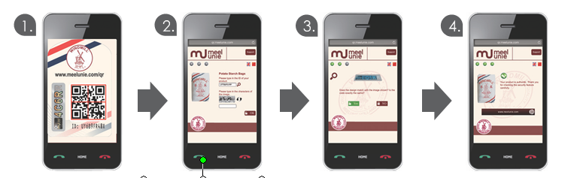



|  |  |  |  |
| --- | --- | --- | --- |
| Scan the  QR code | Enter the characters  of the image | The same code and appearance  as on your product? | Your product is authentic |

**Overall benefits & Return on investment (ROI)**

tesa scribos products are 100% designed, developed and manufactured in the company’s unique production site and headquarters, based in Heidelberg (Germany). From there, they are directly delivered to the client, or in the case of Meelunie, to its exclusive supplier of bags, thus eliminating any possible point of failure in the supply chain. The bag manufacturer is responsible for applying a tesa PrioSpot security label on the Windmill bag before it is send to the potato starch factory. Each tesa PrioSpot security label contains an individual security code as well as various visible and hidden security characteristics, making it impossible to be reproduced or counterfeited.

With a service agreement based on an annual fee plus a small surcharge per label, Meelunie expects a rapid return on investment just by reducing the damage of counterfeits and without necessarily selling that much extra of the product.

**Conclusion**

When interviewed only nine months after the implementation of the solution, Jan van Vilsteren says that the company has received very positive feedback from the distributors. They have the impression of a higher demand for products with the label, despite the slightly higher price changed for them. As the market gets more and more saturated with products containing the security label, Meelunie has also noticed a steady growing number of scans through the website (tesa connect & check).

*“The proof is in the pudding! Considering that in China, everything from water bottles to apples is basically protected with a QR code, we think it is already a very good sign to see so many scans. It means that more and more people have recognized the label and that we have done some good communication on what they should pay attention to, how to check what is real and what is not real”, explains Jan. van Vilsteren. “So we clearly met our objective to create a tool to distinguish the genuine material from the very well copied counterfeit material and to protect the brand value. Over time, we hope to generate a real surge in demand and a gain in market share as well, once counterfeit products have been eliminated. tesa PrioSpot and the tesa connect & check platform have made a real difference for our brand. With the scans, we now have a better idea of where the counterfeits are produced and we are able to take more direct actions in those regions.”*

To conclude, Jan van Vilsteren underlines the highly skilled project team at tesa scribos and in particular, the competent advice of Dr. Anne Thielbeer, Meelunie’s dedicated Technical Project Manager at tesa scribos, throughout the project.

10.070 characters including blanks

Please find photos and further information online: <http://www.tesa-scribos.com/eng/company/press_centre>

Further Information:

Fink & Fuchs Public Relations AG

Tanja Diallo

Tel.: +49 (0)611-74131-64

tanja.diallo@ffpr.de

[www.ffpr.de](http://www.ffpress.net)

About tesa scribos:

As a full subsidiary of tesa, tesa scribos GmbH is part of tesa SE, a company in the Beiersdorf Group. Since being established in 2001, the company has become synonymous with expertise in the fields of security and identification, focusing on counterfeiting protection, product tracing, document protection and anti-tampering devices. With years of experience in the conceptual design, development and implementation of customer-specific product protection measures, tesa scribos offers a comprehensive customer advisory service, practicable security concepts and effective protection technologies for manufacturers of original products such as spare car parts, electronic components and consumer electronics, wine and spirits, chemicals, luxury goods, pharmaceuticals and cosmetics. Customers of tesa scribos include leading global companies such as Bosch, Castel, Continental Aftermarket, Danfoss, Mammut and Motor Service International (MSI). tesa scribos solutions include tesa PrioSpot, tesa VeoMark, tesa connect & check, tesa CodeSeal, tesa SecuritySealing, and tesa SecurityPrint. More information on these products can be found at [www.tesa-scribos.com](http://www.tesa-scribos.com)