Press Release

Automechanika 2016, 13-17 September 2016 in Frankfurt, Germany

Motorservice, a spare parts specialist, effectively protects its brand products with security solutions by tesa scribos

Heidelberg, Germany, 08 September 2016. The vehicle parts market is flooded with cheap copies of brand spare parts. According to the European Automobile Manufacturers’ Association (ACEA), the automotive industry loses five to ten billion euros yearly because of the sale of illegally manufactured spare parts. The counterfeit goods cause far more than just economic damages. Fake copies of brake linings and imitations of wheel rims or spark plugs can have dangerous consequences for consumers – the bottom line is: only OEM-quality spare parts can meet the necessary safety requirements.
As a leading manufacturer of engine components, MS Motorservice International places great importance on protecting its products – marketed under the premium brands KOLBENSCHMIDT, PIERBURG and TRW Engine Components as well as manufactured for the brand BF – against counterfeits. The company protects its products using a combination of printed standard industry codes and additional security features. Motorservice has been using tesa Holospot, an innovative anti-counterfeit technology by tesa scribos, to safeguard the printed code with physical verification and protect it from imitation.

How the tesa Holospot technology protects original products
The tesa Holospot label is a label-on-label solution that firmly adheres to the Motorservice product label. The tesa Holospot offers two crucial benefits: the genuineness of the product can be easily verified at first glance, and the product can also be precisely and reliably traced in the distribution chain. With tesa Holospot, an item’s individual code, the brand logo and other unique security features can be recognised with the naked eye or using a magnifying glass. The tesa Holospot is affixed to the printed MAPP code, which clearly identifies every automotive spare part. This way, the product label of Motorservice combines clear product identification with a reliable physical proof of authenticity to make counterfeits immediately identifiable.
Motorservice also uses a packaging seal by tesa scribos to protect goods against tampering in the logistics chain. The seal leaves a permanent proof of opening (void effect) as soon as the package is opened. This not only protects every delivery from theft but also prevents the illegal reuse of the packaging, such as for the sale of counterfeits.
Informing the market about the security measures
Informing the various target groups – such as dealers, custom officials and consumers – about the security solution is just as important as the solution itself. Every point a product passes through along the supply chain will be informed about the things to take note of when verifying a product’s authenticity. Only when this information takes root can the sale of counterfeits be hampered, the number of imitation products be reduced and the grey market trade be combated.
How the authenticity check works is presented in a straightforward manner on the website of Motorservice. Besides basic features such as packaging colour and brand logo, the company also points out the affixing of tesa scribos seal labels, the MAPP code, the tesa Holospot label and the matrix code as the basis for the easy-to-use online check. The great number of online checks shows how successful the security solution is, and the number of online verifications continues to increase. In addition, a safety poster for display in workshops and retail shops is available for download. The combination of communication and physical proof presents an insurmountable hurdle for counterfeiters. This protects the safety of consumers and prevents financial losses for manufacturers.
Motorservice will showcase its solutions at this year’s Automechanika in Hall 4, Booth C42.
3.919 characters including blanks
Please find photos and further information online:
http://www.tesa-scribos.com/eng/company/press_centre

The safety poster gives dealers, retailers and workshop employees a clear look at how they can tell genuine and counterfeit spare parts apart.
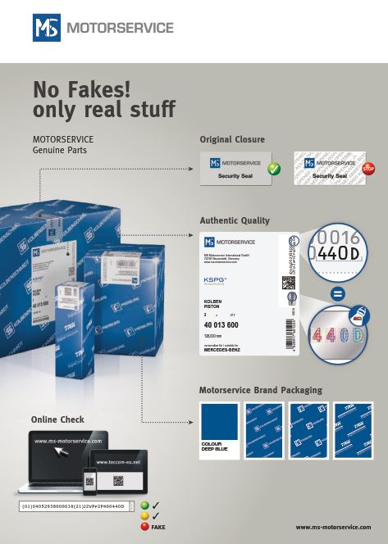

Further Information:

Fink & Fuchs Public Relations AG
Tanja Diallo
Tel.: +49 (0)611-74131-64
tanja.diallo@ffpr.de
www.ffpr.de

About tesa scribos:
As a full subsidiary of tesa, tesa scribos GmbH is part of tesa SE, a company in the Beiersdorf Group. Since being established in 2001, the company has become synonymous with expertise in the fields of security and identification, focusing on counterfeiting protection, product tracing, document protection and anti-tampering devices. With years of experience in the conceptual design, development and implementation of customer-specific product protection measures, tesa scribos offers a comprehensive customer advisory service, practicable security concepts and effective protection technologies for manufacturers of original products such as spare car parts, electronic components and consumer electronics, wine and spirits, chemicals, luxury goods, pharmaceuticals and cosmetics. Customers of tesa scribos include leading global companies such as Bosch, Castel, Continental Aftermarket, Danfoss, Mammut and Motorservice International (MSI). tesa scribos solutions include tesa PrioSpot, tesa VeoMark, tesa connect & check, tesa trust & trace, tesa SecuritySealing, and tesa SecurityPrint. More information on these products can be found at www.tesa-scribos.com

