Press Release

The Saint-Emilion Wine Council security label: a unique and efficient system to guarantee authenticity and traceability!
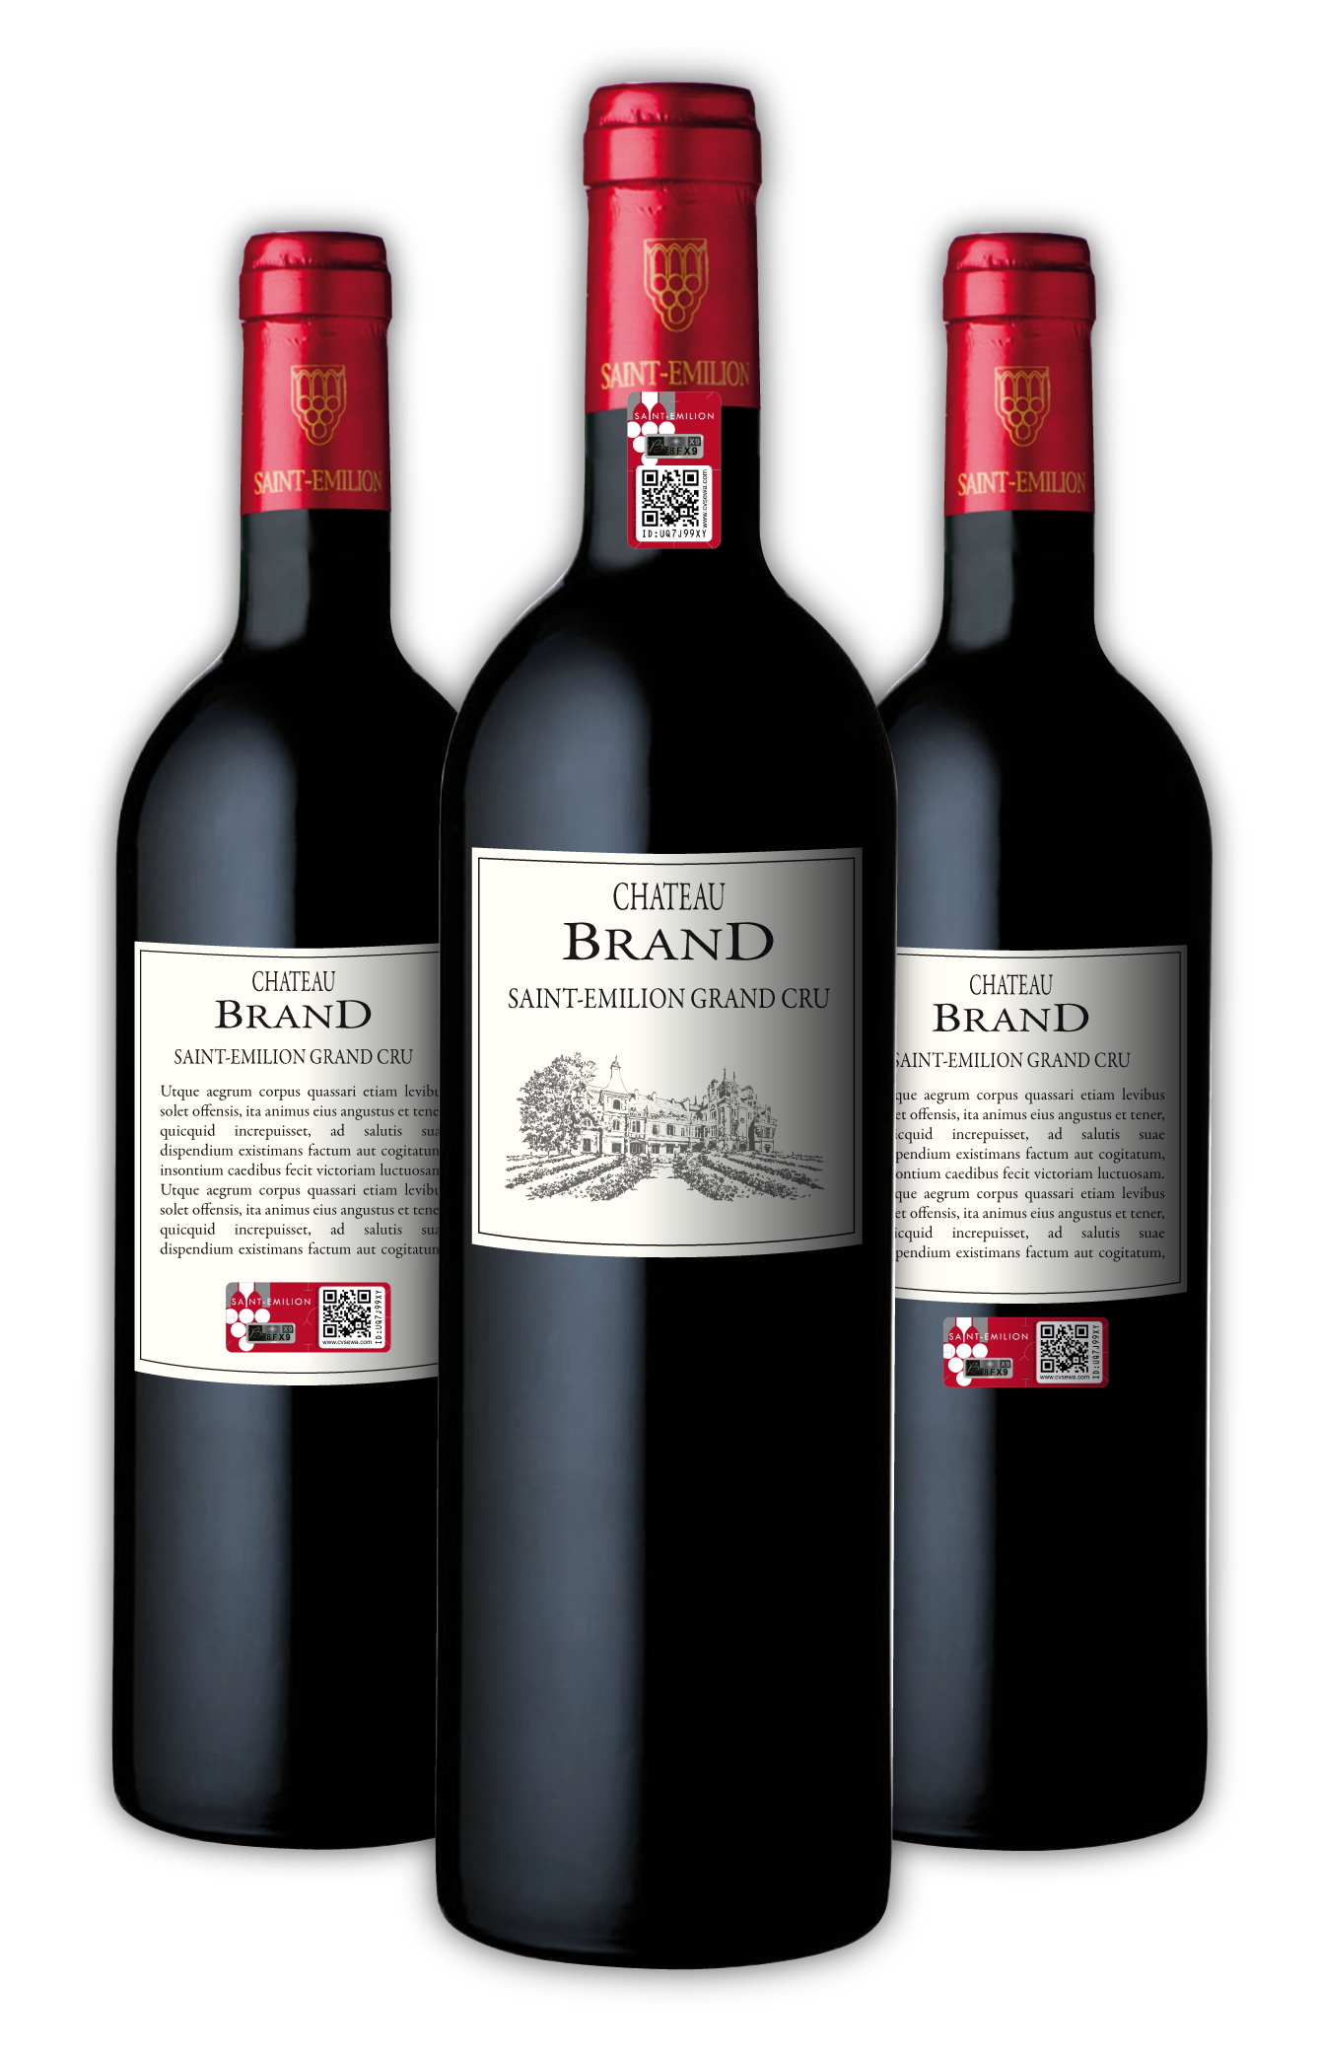
Stronger together: The Saint-Emilion Wine Council takes stock of the tesa scribos security solution. After being introduced in a 2015 pilot phase only for the “Saint-Emilion appellation”, the system is now also available for all of the Puisseguin Saint-Emilion and Lussac Saint-Emilion wines.

Heidelberg / Paris, 02 November 2016 – The Saint-Emilion Wine Council announces the continuation of the Saint-Emilion security label. The programme, launched in 2015, was initially reserved for the Saint-Emilion designation and has now extended its availability to all the wines under the Saint-Emilion Wine Council. The solutions will also be shown at the 20th edition of Vinitech Sifel, 28 November to 1 December 2016, at the Parc des Expositions, Bordeaux-Lac, HALL 1 D 2502.

Since bringing together the Saint-Emilion, Lussac Saint-Emilion and Puisseguin Saint-Emilion associations in 2007, the Saint-Emilion Wine Council is now France’s oldest viticultural association and continues evolving, constantly reinforced with new members. Aside from promoting the Saint-Emilion designations and completing missions confided by the State, the Saint-Emilion Wine Council is active in the AOC (Appellation d'Origine Contrôlée). Its role consists of making a large palette of advice and services available to its members in all areas concerning the production cycle: wine sector regulation, oenology, viticulture, training and brand protection.

Brand protection is increasingly important in the age of globalisation, faced with the counterfeiting problem. According to a July 2016 report by the European Union Intellectual Property Office (EUIPO), France is the fourth most affected country. French companies are losing €136 million annually, while the Treasury sees hundreds of millions of Euros disappear in uncollected excise duties. The problem not only makes things difficult from the perspective of lost turnover and damaged brand reputations, but also poses risks to jobs in the industry as well as to consumer health and safety.
One of the most threatened sectors in France is the wine and spirits market. All the vineyards – from the largest to the smallest – seem concerned. Many châteaux have already adopted and implemented individual authentication measures for their wines. Thus, the more modest and less well-known producers often do not have the financial means to ensure traceability and to push counterfeits of their brand out of the market.

It is in this optic that the Saint-Emilion Wine Council wanted to find a collective protection and traceability solution. One that could give all members the benefits of a mutual cost-sharing efficient, easy-to-implement and affordable solution thanks to economies of scale.

Choosing the solution
In October 2015, after a 12-month study and testing period, the Saint-Emilion Wine Council chose tesa scribos security labels, a solution already tested and widely used in the French wine and spirits industry for over 10 years. Notable organisations and many estates in the Bordeaux region successfully used and recommend the tesa scribos security solution, including the Bordeaux et Bordeaux Supérieur (BBS) Association, Cos d’Estournel, the CASTEL Group, Maison Galhaud (comprising Château Rose Brisson, Moulin Galhaud et Château la Haute Rouchonne), Château Haut Veyrac, Château La Marzelle, Vignobles Carles, Vignobles Meynard and many others.

The Saint-Emilion guarantee stamp uses tesa VeoMark technology
Interested growers purchase the security label directly from the Saint-Emilion Wine Council. They can benefit from a special price and low minimum quantity orders (from 1000 labels). Then, the Châteaux simply need to visit the Saint-Emilion Wine Council extranet and activate their labels.
The solution developed in close collaboration between tesa scribos and the Saint-Emilion Wine Council, is based on tesa scribos’s self-developed tesa VeoMark technology, an adhesive label that can be applied astride the capsule and bottle or on the back label.
For the winemakers who do not have a third head on the bottling line, the Saint-Emilion Wine Council offers a custom-made solution to apply the label on the back label.
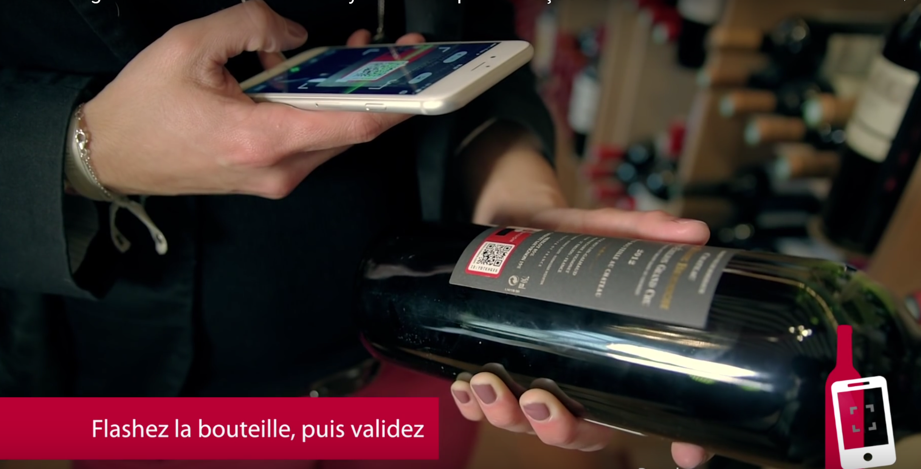
“Thanks to our self-developed technology, each security label is unique and very simple to verify. With the tesa connect & check platform you can check the authenticity of the bottles online.” explained Damien Guille, Regional Sales Manager for SWEU at tesa scribos. “All you need to do is scan the QR code with a smartphone and enter the security code present on the bottle. If the code is valid and confirmed by the consumer, the latter is automatically switched over to the product details provided by the estate on the Saint-Emilion Wine Council website (or that of the winemaker)”.
On these websites, the participating growers can also simply and with full confidentiality provide information on the traceability of each lot well in advance. This allows them to establish the link between the lot and the scanned bottle. Furthermore, they can find statistics on the number of scans, the cities and countries where consumers, customs agents, distributors, etc. have verified their bottles. Like this they are able to collect detailed market intelligence data.
For even greater comfort and simplicity, the Saint-Emilion Wine Council extranet offers growers the option of completing all of the reporting formalities online on the extranet. Among other things, the tool allows them to stay informed in real time and to access a document base.

The advantages
Participation in the programme is voluntary. While the security labels were initially reserved for the Saint-Emilion Grand Cru wines, they are now available to all wines bearing the Saint-Emilion designation.
The Saint-Emilion security label is a reliable and easy-to-implement system for traceability and anti-counterfeiting that has been adopted by many members, allowing them to
- reassure consumers;
- help protect and strengthen the image of the Saint-Emilion wines,
- augment sales in France and abroad;
- enable traceability and simplify the work of distributors and security services such as customs agents in ensuring the products’ authenticity; and
- reduce lost turnover associated with missed profits and brand image damage caused by counterfeit products in circulation.

Communicate to inform and ensure the success of an anti-counterfeiting campaign
The Saint-Emilion Wine Council has set up some powerful marketing tools, including a very effective online video presentation aimed at producers, distributors and security services.

The security labels have also been presented to and unanimously approved by Chinese authorities and distributors in December 2015:
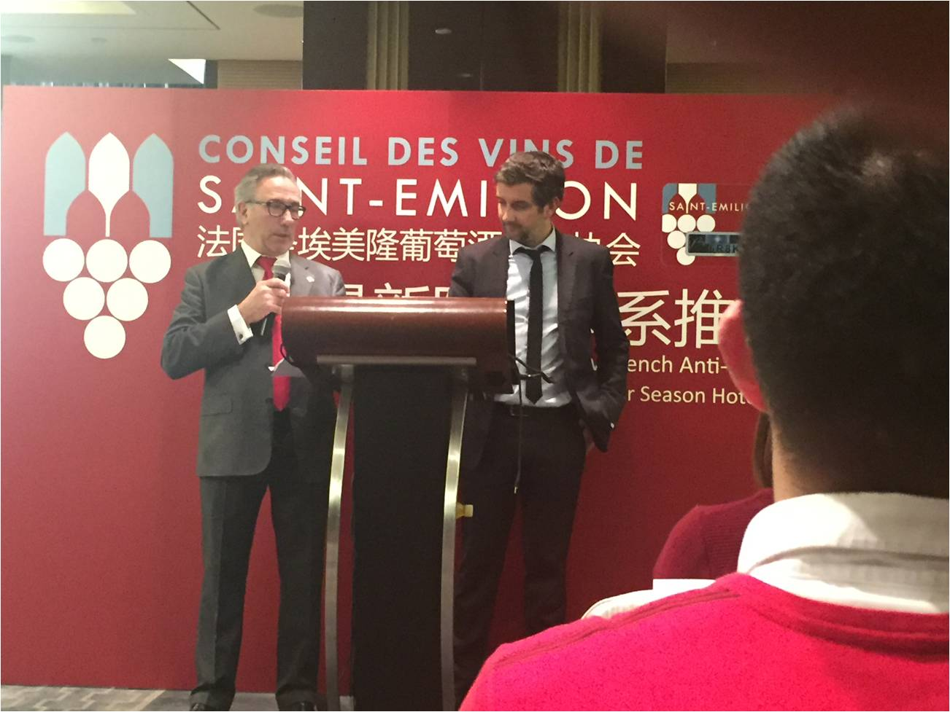
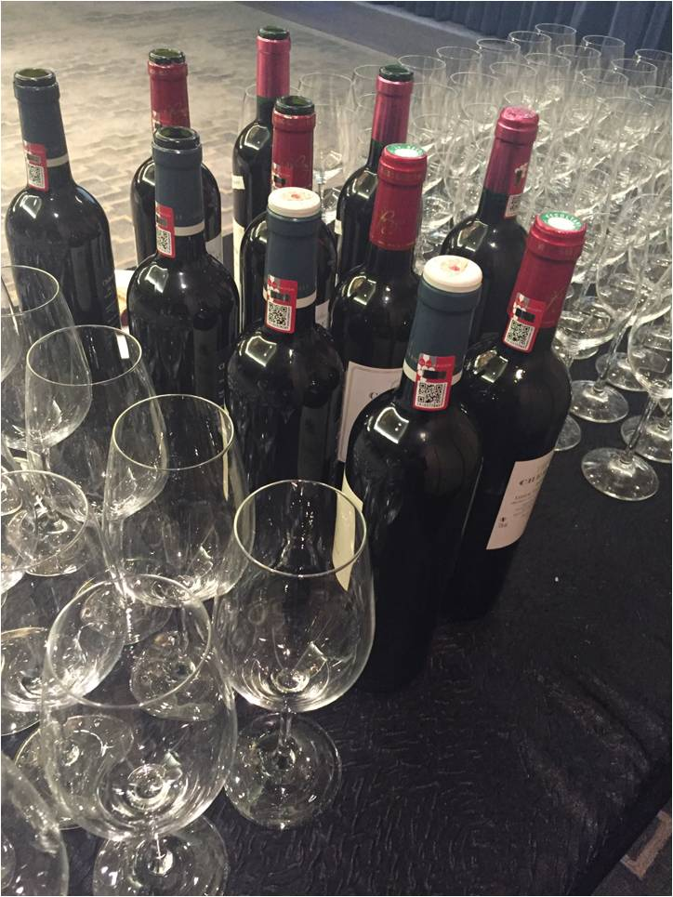
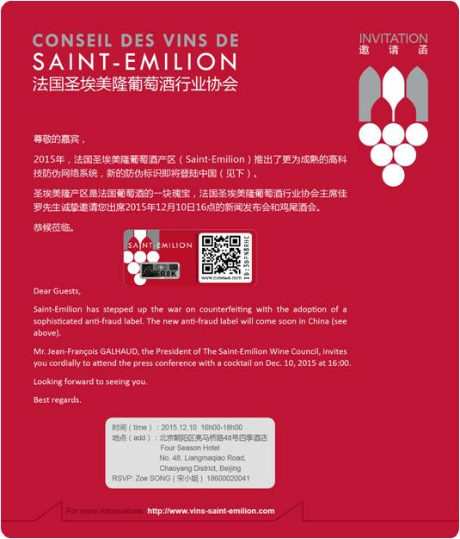

“The close collaboration with the tesa scribos team has allowed us to implement a solution adapted to the size of our family operations (averaging 8 hectares). We chose a security solution that can be used by all of our growers, without any operational constraints. The solution is very flexible, both from the viewpoint of implementation and the advice and participation of the growers, who benefit from personalised advice from our teams and those of tesa scribos. Thanks to the low minimum quantity orders, the solution allows all growers to enjoy the same advantages and thus to mutually make use of a high-level security and traceability solution”, said Frank Binard, Director of the Saint-Emilion Wine Council.
7.514 characters including blanks

If you are interested in this subject, please contact Tanja Diallo from Fink & Fuchs PR.
tesa scribos and the Saint-Emilion Wine Council will also be present and very happy to offer a live demonstration of the solution and tools at Stand D2502, Hall 1, at the Vinitech Sifel exhibition (Bordeaux, 2 November – 1 December).

Please find photos and further information online:
http://www.tesa-scribos.com/eng/company/press_centre

Further Information:

Fink & Fuchs Public Relations AG
Tanja Diallo
Tel.: +49 (0)611-74131-64
tanja.diallo@ffpr.de
www.ffpr.de

About tesa scribos:
As a full subsidiary of tesa, tesa scribos GmbH is part of tesa SE, a company in the Beiersdorf Group. Since being established in 2001, the company has become synonymous with expertise in the fields of security and identification, focusing on counterfeiting protection, product tracing, document protection and anti-tampering devices. With years of experience in the conceptual design, development and implementation of customer-specific product protection measures, tesa scribos offers a comprehensive customer advisory service, practicable security concepts and effective protection technologies for manufacturers of original products such as spare car parts, electronic components and consumer electronics, wine and spirits, chemicals, luxury goods, pharmaceuticals and cosmetics. Customers of tesa scribos include leading global companies such as Bosch, Castel, Continental Aftermarket, Danfoss, Mammut and Motor Service International (MSI). tesa scribos solutions include tesa PrioSpot, tesa VeoMark, tesa connect & check, tesa trust & trace, tesa SecuritySealing, and tesa SecurityPrint. More information on these products can be found at www.tesa-scribos.com

