Press release 25 February 2020

An innovative guarantee stamp for Côtes du Rhône AOCs wines
Beyond authenticating the wine, the Côtes du Rhône guarantee stamp goes much further by ‘speaking’ to the consumer. It can be used for AOC Côtes du Rhône, Côtes du Rhône Villages and Crus.

The Côtes du Rhône guarantee stamp originated from the will of the President of the General Union of Vintners, Philippe Pellaton, to protect the Côtes du Rhône AOCs against infringement.
The idea was to find a simple, effective and inexpensive anti-counterfeiting device.
The tender was awarded to the tesa scribos company, with its ‘four-level security guarantee stamp’, which has already been tested in other wine regions as well as for automotive spare parts, for example.
Each stamp is indeed unique, allowing authentication of each bottle. The stamp is also tear-proof and tamper-proof. It contains a QR code which, once scanned with a smartphone, shows a number that must be identical to that written on the stamp. Otherwise, the consumer is invited to send an alert to the producer, with a photo of the bottle, for example. Other security guarantees are also present, some invisible to the naked eye.
But the Côtes du Rhône guarantee stamp goes much further, as it allows communication with the consumer.
Indeed, after having authenticated the wine, the latter can click on various information buttons: product sheet, company website, Côtes du Rhône website, local distributor, contests, calorie info, environmental policy, etc. It can even send a message directly to the producer.
On its stamp management platform, the producer can geolocate the scans very precisely anywhere in the world, allowing monitoring of the physical locations of the bottles.
“It is a very powerful modern tool on the level of the appellation that speaks to the consumer”, Pellaton said gladly. “Not only does it meet our need for authentication, it also carries communication and marketing elements that make the difference.”
The stamp is operational; it can be used for AOC Côtes du Rhône, Côtes du Rhône Villages and Crus des Côtes du Rhône.
A number of houses (Maison Sinnae, Domaine Denis Alary, Union Rhonéa) have already introduced it on some of their vintages or will soon do so.

More information:
Francine Tallaron, f.tallaron@syndicat-cotesdurhone.com Tel. 04 90 27 24 62
Laurent Jeanneteau, l.jeanneteau@syndicat-cotesdurhone.com Tel. 04 90 27 24 69
Damien Guille, Damien.Guille@tesa.com Tel. 06 22 58 26 58

25 February 2020
Press release

An innovative guarantee stamp
for Côtes du Rhône AOCs wines
Wine Paris Event 2020

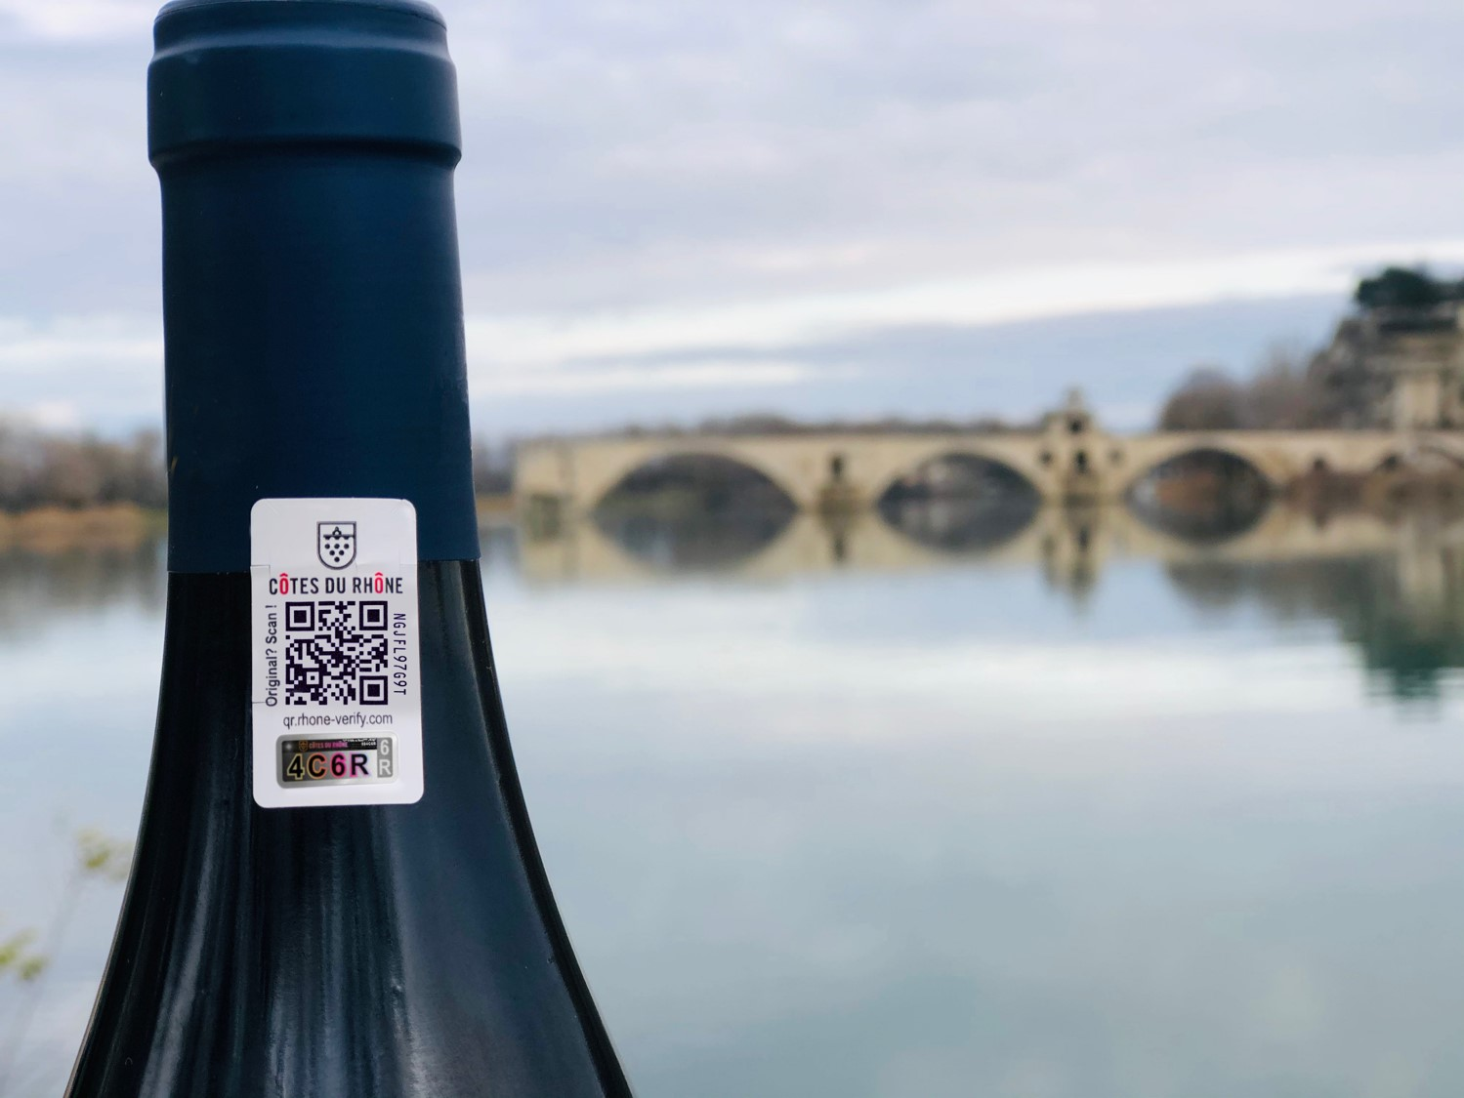

More information :
Syndicat des Côtes du Rhône:
Francine Tallaron, f.tallaron@syndicat-cotesdurhone.com, Tel. 04 90 27 24 62
Laurent Jeanneteau, l.jeanneteau@syndicat-cotesdurhone.com, Tel. 04 90 27 24 69
tesa scribos®:
Damien Guille, Damien.Guille@tesa.com, Tel. 06 22 58 26 58
1/ Why a guarantee stamp for AOC Côtes du Rhône wines?

Fighting against counterfeiting of AOC Côtes du Rhône
A 2018 study by the European Union Intellectual Property Office revealed that counterfeit wines and spirits benefitting from a geographical indication cause an annual loss of €2.7 billion in the EU, including €235 million in France.
The study also assesses the job losses in the EU linked to these counterfeits to more than 6000 direct jobs and 38,800 indirect jobs in the wine and spirits sector.
The Côtes du Rhône are, unfortunately, not spared, as evidenced by the multiplication of attacks noted in recent years. In this context, Philippe Pellaton, President of the Union of Winemakers Côtes Du Rhône, made protection of the name ‘Côtes du Rhône’ a major issue in his fourth term as head of the second largest appellation vineyard in France.
The Union Côtes du Rhône then adopted a real defence strategy for the name Côtes du Rhône, incorporating an ambitious project: that of developing an unfalsifiable authentication system at the appellation level.
The initial objective of this project was the development of an effective tool to combat counterfeiting and usurpation of the name ‘Côtes du Rhône’. The launch of such a device at the Côtes du Rhône appellation level allows harmonisation of the devices, avoiding the multiplication of anti-counterfeiting tools, which would not favour effective action at the appellation level and would be difficult for the consumer to read.
The development of such a project on the level of the appellation also aims to give as many people as possible access to a device to combat counterfeiting. However, beyond the fight against counterfeiting and usurpation of the Côtes du Rhône appellation, there is also the question of protecting the producers’ brands, which are also subject to counterfeiting. Thus, each structure, whatever its size, can utilise the tool to defend its own intellectual property rights, while ensuring the traceability of its products.

Speak directly to the consumer
In addition, the ambition of the Côtes du Rhône Union was to take advantage of the authentication device’s implementation to go farther in terms of communication with the consumer.
For example, giving the marketer the opportunity to access the wine product sheet, direct access to his website, more general information on the appellation, the list of ingredients, the possibility of proposing commercial offers, etc.

Having a global vision of the Côtes du Rhône market
Finally, the Union wanted to exploit another aspect of the system, going hand in hand with the product traceability function: to obtain a precise, real-time vision of the Côtes du Rhône market in the world.
Thanks to consumer scans, the Union will be informed of the place where the product is located and will be able to know precisely the countries and regions in which Côtes du Rhône wines are consumed, allowing it to adapt its collective communication on growth markets and conquer new markets. Of course this possibility is not open only to the Union, each producer will be able to know the places of consumption of his products.

2/ The guarantee stamp from tesa scribos®, a solution chosen by the Union of Côtes du Rhône

A high-performance authentication tool
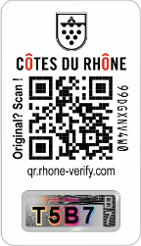
Following a call for tenders, the Union of Côtes du Rhône chose tesa scribos®, with which it signed a contract in October 2019.
Tesa scribos® markets a guarantee stamp with four security levels: a level visible to the eye by any user, a semi-visible level using a tool, and two hidden levels which can only be studied in a laboratory. These different levels make the device tamper-proof and extremely secure.
This performance as well as tesa scribos’® experience in developing guarantee stamps in other regions (Bordeaux, Saint-Emilion, Crus Bourgeois, etc.), are the primary reasons why the Union of Côtes du Rhône chose this company. The cost of the device is also competitive for a device of this scope. It will be offered on a strictly voluntary basis.

A real tool for communication with the consumer
But the stamp goes beyond a simple authentication tool, it gives the bottles a voice. Once the product has been authenticated, the consumer can access all the information communicated to him by the producer: the wine’s place of production and sale, method of production, method of consumption, grape varieties, terroirs, the estate or cellar website, calories, etc.
The producer can even create a real interaction with the customer by offering participation in contests, invitations to events or soliciting opinions on the product.
With this communication component, the Union meets the expectations of a new generation of connected consumers for whom everything must be accessible to a smartphone and who do not hesitate to pay more for an ethical and authentic product.
Thus, the guarantee stamp, in addition to attesting to the origin of a product, will be able to highlight the actions carried out by the sector or the producer to engage in a more virtuous approach for the environment, such as the Union’s Biodiversity Plan, the Landscape Charter, the High Environmental Value collective approach, etc.
The producer will know where the bottles have been scanned, allowing command of the distribution network and enabling adaptation of the offer to the demand.

A stamp that can eventually serve as a ‘tax passport’
The guarantee stamp thus assumes several roles: authenticator, communication tool and perhaps eventually a ‘tax passport’.
Indeed, discussions are under-way with the Customs Administration to make the guarantee stamp a transport permit allowing the circulation on French territory of goods with paid excise duty in lieu of the Legal Capsule [French: CRD], thus greatly reducing administrative burdens for producers.

The stamp is a promotion tool for products in France but also for export. Foreign consumers, whose geographic distance does not always allow them to be notified, will now be certain, by buying a bottle fitted with a stamp, that the wine is indeed a Côtes du Rhône made in France by a given producer. The Côtes du Rhône will therefore be one step ahead on the export markets!
The guarantee stamp is an innovative technology responding to new societal challenges, which will undoubtedly boost the Côtes du Rhône appellation.

Damien Guille, tesa scribos Sales Director for South-West Europe:
“A stamp that benefits from the latest digital developments”
“We have been in contact with the Union of Côtes du Rhône Union for several years already. It is therefore with enormous satisfaction that we support it in the deployment and communication of the guarantee stamp and the defence strategy of the name ‘Côte du Rhône’.”
The Côtes du Rhône stamp, although using the same technology (Tesa VeoMark) and the same structure as the stamp already deployed by other unions and large wine and spirits groups, benefits from the latest digital developments in order to go even farther in consumer protection and interaction.
We are at the end of more than 12 months of work. Enormous teamwork has been undertaken, both on tesa's side and on the Union side. Indeed, the developed solution is based on an almost daily exchange between the communications, legal and IT departments, without forgetting technical visits for integration on the packaging line.
We have already registered the first stamp orders on the online platform, and the exchanges with the operators are strong and enthusiastic.
The Côtes du Rhône stamp and all the associated services allow us to enter the digital era, in order to increase interaction with the consumer, and to always be looking for authentic, quality products.”

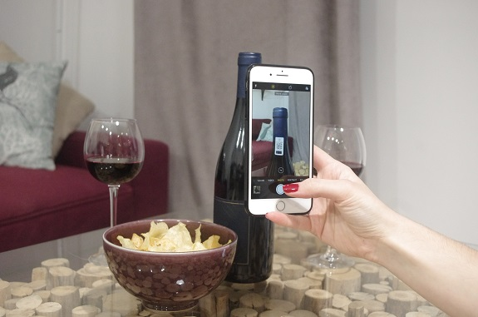
3/ How exactly does it work?

For the consumer
The guarantee stamp, designed by tesa scribos for the Union of Côtes du Rhône, includes a QR code, allowing the consumer to verify that the product is authentic. Once the QR code has been scanned on a smartphone (just by the camera, without an app), consumers are asked to confirm that the identifier that appears on the phone is the same as the one on the stamp (holographic code).
The customer is then immediately informed of whether the product in hand is authentic or not. If the identifier on the smartphone is not the same as the one on the bottle, the consumer is invited to provide information on the product such as the place of sale, photo of the product, etc. The Union and the producer are then directly informed of this disparity and can conduct an investigation based on the elements gathered thanks to the consumer.
If the identifier that appears on the phone is correct, the consumer then has access to the information buttons chosen by the producer and on which he can click: product sheet, website, Côtes du Rhône site, distributor, events, etc.
Depending on the language activated on the consumer's phone, the information will be displayed in French or English.

For the producer
Tesa scribos has developed a platform for ordering and managing custom stamps.
All developmental costs of IT platforms are borne by the Union of Côtes du Rhône.
The device is simple; operators will only have to connect, via the Personal Space of the Union website, to a platform to order their stamps online.
They will be delivered directly to their office.
They will then affix them to their bottles and activate them online on a dedicated and secure platform in order to integrate all the information they wish to communicate to consumers and that kept confidential, which will allow them to ensure the traceability of their wines.
The producer can geolocate scans very precisely anywhere in the world on the management platform.

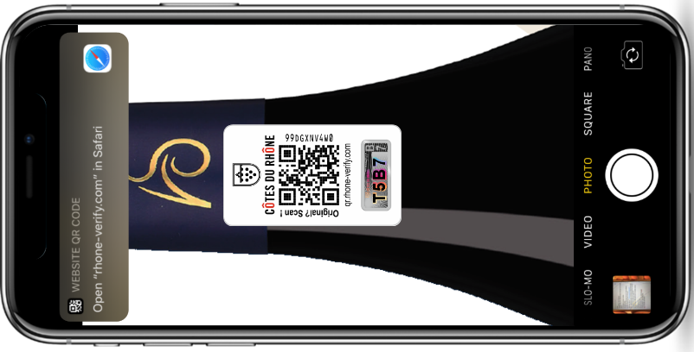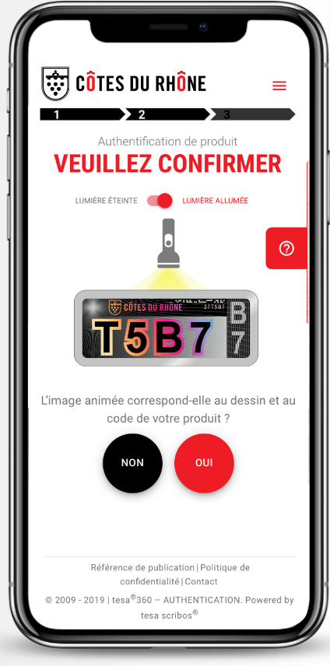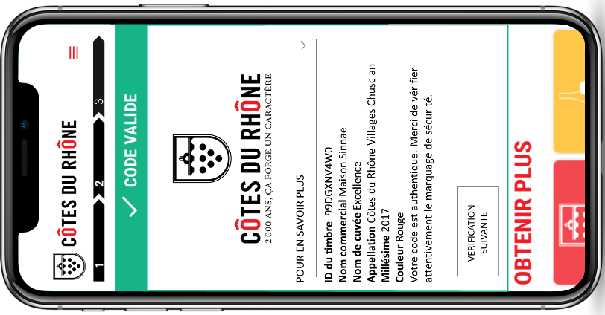

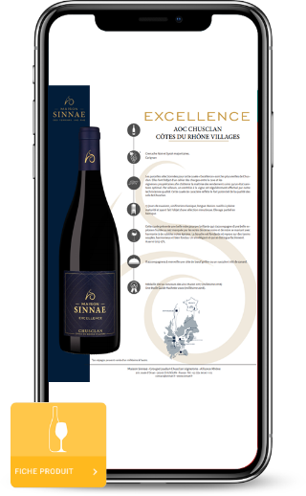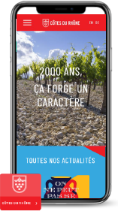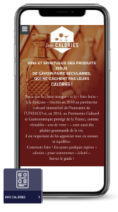

Stamp ordering and management
Via the Personal Space of the Union of Côtes du Rhône website (www.syndicat-cotesdurhone.com)
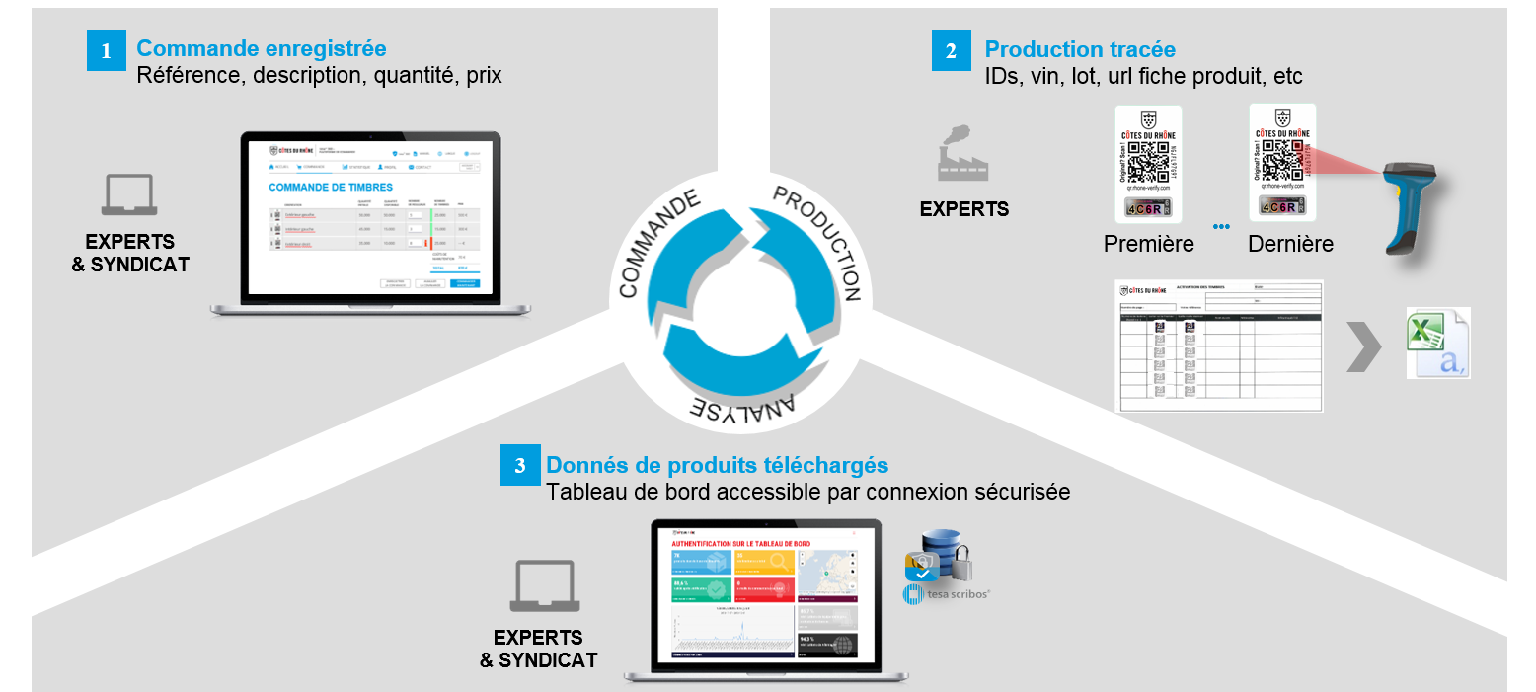
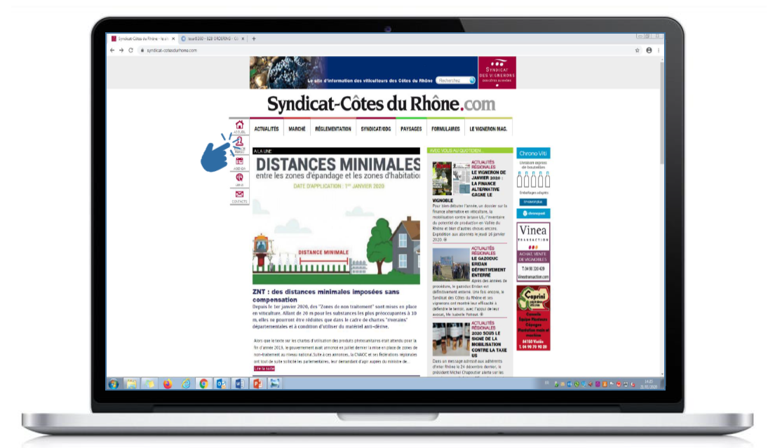

Worldwide localisation of scans
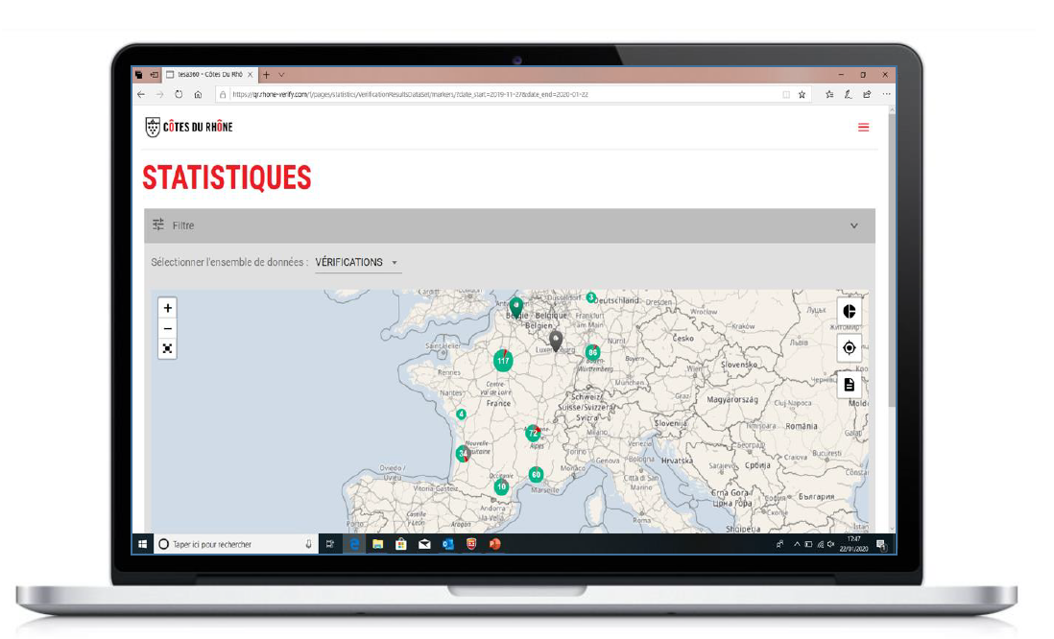
Cellars’ interests in the guarantee stamp
- Digitising label information (ingredients)
- Replacement oft he CRD (discussion initiated with Customs)

Customer’s interests

3/ Implementation timetable
The order and activation platforms are ready and stamps are now available to order.
The guarantee stamp system was presented to vintners at the general meeting of the Union of Côtes du Rhône on 23 January 2020.
It is currently used by several wineries and estates; the first bottles have just been released for the Wine Paris show. The official launch of the guarantee stamp takes place during this fair, notably through a press conference on 11 February 2020.

4/ What the vintners are saying

Philippe Pellaton, President of Maison Sinnae and of the Union of Côtes du Rhône Winegrowers
“A competitive advantage for the Côtes du Rhône AOCs”
“The Côtes du Rhône guarantee stamp is a unique tool available to AOC Côtes du Rhône, Côtes du Rhône Villages and Crus operators, on a voluntary basis. It responds to a need to fight against infringement but also to guarantee the authenticity of these wines to the consumer. For me, it was very important to develop it on the level of these appellations rather than letting companies do it individually.
The interesting thing is that he goes much farther in talking to the consumer. So it is a very powerful, modern tool that I think has a grand future. It can enliven sales outlets in supermarkets or at wine merchants, meals at restaurants or with friends, etc.
At Maison Sinnae, we will present it to our distributor customers in March 2020, explain how it works and first offer it on high-end products. Ultimately, we plan to deploy it widely because it will allow us to communicate about each of our vintages in a differentiated way, by providing the consumer with precise and relevant information.
Now operational, this tool will therefore live its life! We will take stock in a while, but I remain convinced that it constitutes a very important competitive advantage for the AOCs of the Côtes du Rhône."

Denis Alary, winemaker in a private cellar at Domaine Alary in Cairanne:
“A great way to amplify digital communication”
“Today, digital communication through the internet and social networks has become essential for promotion. The guarantee stamp solution proposed by the Union of Côtes du Rhône seems to me perfectly suited to this development. Indeed, each bottle will give the consumer, whether in France or at the other end of the world, information about the wine they buy, the cellar from which it comes, possibly the list of ingredients – should that become mandatory in the future – and many other things, including the possibility of sending a message to the producer.
This digitising avoids a considerable weighing down of the back labels.
Beyond this, the stamp also makes it possible to provide more general information on the appellation but also to relay, directly to the consumer, the promotional campaigns carried out by Inter Rhône.
Finally, I find it very useful to be able to know in which countries my bottles are the most scanned to accentuate, or not, the promotion of my wines.”

„We let your products talk!“
by Damien Guille (tesa scribos®)

From the first discovery that tesa® products can be used for data storage, to unique marking technologies and digital tools – since our founding in 2001, we have developed into a leading solution provider for digital transformation at the product level.
For brands that want to go digital, we connect their products with the digital world. By creating unique markings and digital tools, we let your products communicate with consumers, exchange data, and interact with track & trace systems. Together, we analyse your needs, develop your customized solution, and manage everything from idea to implementation – and beyond.
In short, we LET YOUR PRODUCTS TALK and offer new benefits from digitalization.
As a full subsidiary of tesa®, we are part of tesa SE within the Beiersdorf Group. The profound experience of Beiersdorf in international brand management with its own global brands such as Nivea and Eucerin, as well as the expertise of tesa® with market-leading adhesive solutions, is merged with the pioneering digital competence of tesa scribos®. This exceptional combination enables us to design unique solutions for our international customers from all kinds of industries. Based on extensive consultations, we develop, customize and implement solutions – all from one source. Our clients include world-leading companies such as Peugeot, Bosch, Castel, Danone and Chloé.

For more information: Damien Guille, Damien.Guille@tesa.com, Tel. 06 22 58 26 58, www.tesa-scribos.com

